**Name: Session:**

**Programming II**

**Making a Tic-Tac-Toe Game**

**Lab Exercise 5.4.2020**

1. Start by building the following interface. The interface should contain 11 buttons and a label.

The controls should have the following names:

|  |  |
| --- | --- |
| **Name** | **Purpose** |
| btnLeftUpper | To place an X or an O in the left upper square |
| btnMiddleUpper | To place an X or an O in the middle upper square |
| btnRightUpper | To place an X or an O in the right upper square |
| btnLeftMiddle | To place an X or an O in the left middle square |
| btnMiddleMiddle | To place an X or an O in the middle middle square |
| btnRightMiddle | To place an X or an O in the right middle square |
| btnLeftLower | To place an X or an O in the left lower square |
| btnMiddleLower | To place an X or an O in the middle lower square |
| btnRightLower | To place an X or an O in the right lower square |
| btnReset | To reset the game |
| btnQuit | To exit the game |
| lblWin | Displays winner message |

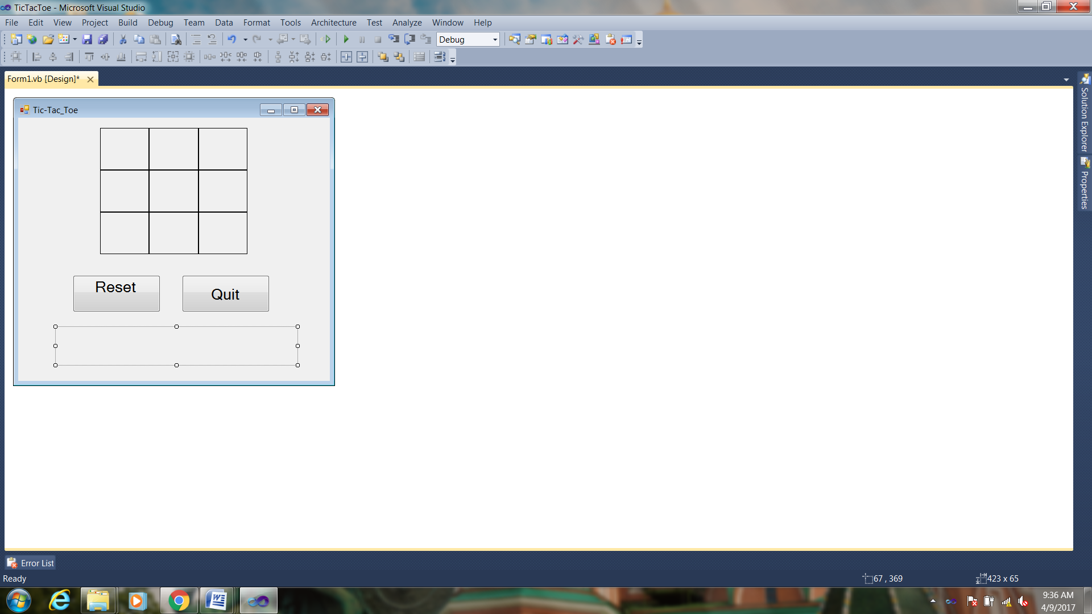

2. Add the following global variables

bool player;

bool disabled1;

bool disabled2;

bool disabled3;

bool disabled4;

bool disabled5;

bool disabled6;

bool disabled7;

bool disabled8;

bool disabled9;

3. Add the following code to the Form1_Load Sub

player = true;

disabled1 = false;

disabled2 = false;

disabled3 = false;

disabled4 = false;

disabled5 = false;

disabled6 = false;

disabled7 = false;

disabled8 = false;

disabled9 = false;

4. Add the following two functions to your program. The first function will check to see if a player has won and the second will lock the cells after they have been selected.

private void checkWin()

{

playerX_Win();

playerO_Win();

}

private void lockCells()

{

btnLeftUpper.Enabled = false;

btnMiddleUpper.Enabled = false;

btnRightUpper.Enabled = false;

btnLeftMiddle.Enabled = false;

btnMiddleMiddle.Enabled = false;

btnRightMiddle.Enabled = false;

btnLeftLower.Enabled = false;

btnMiddleLower.Enabled = false;

btnRightLower.Enabled = false;

}

5. Now we will add two functions that will check if playerX or playerO has won.

private void playerX_Win()

{

if (btnLeftUpper.Text == "X" && btnMiddleUpper.Text == "X" && btnRightUpper.Text == "X")

{

lblWin.Text = "Player X Wins";

lockCells();

}

if (btnLeftLower.Text == "X" && btnMiddleLower.Text == "X" && btnRightLower.Text == "X")

{

lblWin.Text = "Player X Wins";

lockCells();

}

if (btnLeftMiddle.Text == "X" && btnMiddleMiddle.Text == "X" && btnRightMiddle.Text == "X")

{

lblWin.Text = "Player X Wins";

lockCells();

}

if (btnLeftUpper.Text == "X" && btnLeftMiddle.Text == "X" && btnLeftLower.Text == "X")

{

lblWin.Text = "Player X Wins";

lockCells();

}

if (btnMiddleUpper.Text == "X" && btnMiddleMiddle.Text == "X" && btnMiddleLower.Text == "X")

{

lblWin.Text = "Player X Wins";

lockCells();

}

if (btnRightUpper.Text == "X" && btnRightMiddle.Text == "X" && btnRightLower.Text == "X")

{

lblWin.Text = "Player X Wins";

lockCells();

}

if (btnLeftUpper.Text == "X" && btnMiddleMiddle.Text == "X" && btnRightLower.Text == "X")

{

lblWin.Text = "Player X Wins";

lockCells();

}

if (btnRightUpper.Text == "X" && btnMiddleMiddle.Text == "X" && btnLeftLower.Text == "X")

{

lblWin.Text = "Player X Wins";

lockCells();

}

}

Note: playerO_Win() is similiar

6. Now we will write code for the 9 cell button click events:

private void btnLeftUpper_Click(object sender, EventArgs e)

{

if (player)

{

if (!disabled1)

{

btnLeftUpper.Text = "X";

player = !player;

disabled1 = true;

}

}

else

{

if (!disabled1)

{

btnLeftUpper.Text = "O";

player = !player;

disabled1 = true;

}

}

checkWin();

}

7. The Click event handlers for btnMiddleUpper, btnRightUpper, btnLeftMiddle, btnMiddleMiddle, btnRightMiddle, btnLeftLower, btnMiddleLower, and btnRightLower are similar.

8. Next we will add the code for the btnReset and btnQuit click events.

private void btnReset_Click(object sender, EventArgs e)

{

player = true;

disabled1 = false;

disabled2 = false;

disabled3 = false;

disabled4 = false;

disabled5 = false;

disabled6 = false;

disabled7 = false;

disabled8 = false;

disabled9 = false;

btnLeftUpper.Enabled = true;

btnMiddleUpper.Enabled = true;

btnRightUpper.Enabled = true;

btnLeftMiddle.Enabled = true;

btnMiddleMiddle.Enabled = true;

btnRightMiddle.Enabled = true;

btnLeftLower.Enabled = true;

btnMiddleLower.Enabled = true;

btnRightLower.Enabled = true;

btnLeftUpper.Text = "";

btnMiddleUpper.Text = "";

btnRightUpper.Text = "";

btnLeftMiddle.Text = "";

btnMiddleMiddle.Text = "";

btnRightMiddle.Text = "";

btnLeftLower.Text = "";

btnMiddleLower.Text = "";

btnRightLower.Text = "";

lblWin.Text = "";

}

9. Enjoy the game....

**Print a screen shot of a game you played, attach it to this sheet and turn in.**